7.Pips-forbs model simulation

2020112921 刘欣豪

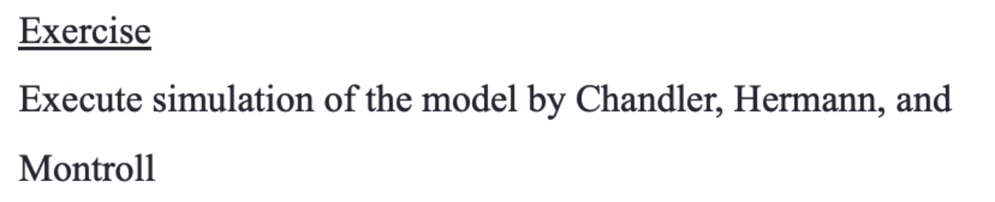

输出output表（部分）：

|  |  |  |  |  |  |
| --- | --- | --- | --- | --- | --- |
| **Time (second)** | **Position (meter) of lead car** | **speed of lead car** | **Position (meter) of follow car** | **speed of follow car** | **acceleration** |
| 0 | 2000 | 0 | -102 | 0 | 0 |
| 1 | 2000 | 0 | -102 | 0 | 0 |
| 2 | 2000 | 0 | -102 | 0 | 0 |
| 3 | 2000 | 0 | -102 | 0 | 0 |
| 4 | 2000 | 0 | -102 | 0 | 0 |
| 5 | 2000 | 0 | -102 | 0 | 0 |
| 6 | 2000 | 0 | -102 | 0 | 0 |
| 7 | 2000 | 0 | -102 | 0 | 0 |
| 8 | 2000 | 0 | -102 | 0 | 0 |
| 9 | 2000 | 0 | -102 | 0 | 0 |
| 10 | 2000 | 0 | -102 | 0 | 0 |

仿真结果：

轨迹高度重叠，不符合现实

代码：

1. **import** pandas as pd
2. datas = pd.read_excel('Lead+car+data.xlsx')
4. **for** i **in** range(0,500):
6. datas.iloc[i,5] = datas.iloc[i,2] - datas.iloc[i,4]
7. datas.iloc[i+1,4] = datas.iloc[i,4]+datas.iloc[i,5]
8. datas.iloc[i+1,3] = datas.iloc[i,3]+datas.iloc[i+1,4]
10. datas.to_excel('output.xlsx',index  =False)